Skilling the Territory Annual Investment Plan 2018/19
November 2018

Contents
Minister’s foreword 4
What we’ve achieved so far 5
Investment priorities 8
Economic Development Framework 8
Major projects 8
Industry 8
Cohorts 9
Regional snapshot 10
Programs 11
Apprenticeships and traineeships - $28.7 million 11
Training (User Choice) - $21 million 11
Employer incentives and apprentice and trainee support - $6 million 12
Employer Incentives - $4.2 million 12
Supercharge Business Bonus 12
Work Wear/Work Gear Bonus - $1 million 12
Apprentices/Trainees Travel and Accommodation costs - $750,000 12
Australian Apprenticeships NT - $1.7 million 12
Targeted and responsive - $7.9 million 13
New Territory Workforce Program - $3 million 13
Industry Buildskills Program - $1 million 13
Aboriginal employment programs - $3.3 million 13
Aboriginal Workforce Grants - $970,000 13
Aboriginal Responsive Skilling Grants - $2.3 million 13
Pre-Employment Program - $250,000 13
Equity Program - $300,000 14
Public provider investments - $56.3 million 14
CDU - $44.4 million, Batchelor - $11.9 million 14
Industry engagement - $3.3 million 14
Australian Government - $14.5 million* 14
Other services 15
Workforce training coordinators 15
Migration support services 15
MigrationNT 15
Worker Attraction Program 15
Events 15
NT Training Awards 15
Skills, Employment and careers expo 16
Worldskills 16
The VET investment framework 16
Key outcomes 17
Outcomes 17
What we will do 17
Conclusion 17
Contacts 18

Minister’s foreword
The Territory Government is committed to skilling the Territory’s workforce to do the jobs of today and the future. This commitment is backed by an investment of $93 million in 2018/19
The Skilling the Territory Annual Investment Plan directs training funding to help Territorians gain the skills they need to secure and retain jobs created by business, industry and government. The Territory has one of the highest vocational education and training participation rates nationally, with 21,391 students undertaking publicly-funded training. We must capitalise on this strength and direct skills development to areas where it will make a real difference, to help build the capacity and productivity of our priority industries.
The Government’s strategic investment under the Plan supports the Northern Territory Economic Development Framework goals. It lays the foundation to support the economic growth sectors; defence and support industries, agribusiness, tourism, energy and minerals, and international education and training, as well as the developing sectors; tropical health, human services, creative industries, renewables and environmental services.
More than 137,710 people are employed across 19 industry sectors in the Northern Territory. Our investments will be targeted to areas where there is industry demand and benefit to the public. This will then contribute to the Territory’s economic success.
Industry will be at the forefront of Government funding decisions, from the upskilling of existing workers to training new entrants to the workforce. Training providers will continue to link with industry and employers to provide quality training to meet their needs
Apprentices and trainees, and the businesses that employ them, are the core of the Northern Territory’s workforce and essential to the Territory economy. The NT Government has committed $28.7 million to train and support apprentices and trainees, and to reward employers who take them on with the release of a new and simplified financial incentive scheme, the Employer Apprenticeship and Traineeship Support Scheme. In June 2018, the NT Government signed the National Partnership on the Skilling Australians Fund to support growth in the Apprenticeship and Traineeship space.
We will continue to engage positively with businesses, industry associations, peak bodies, the national training regulator and training organisations, and advocate for the Territory with the Australian Government to ensure the skills we invest in are relevant and of the highest standard.
The Plan provides additional support for employers to develop and retain their workforce who are Aboriginal or from equity groups.
We will also continue to strengthen training pathways for Aboriginal Territorians through targeted training programs to improve access and participation in practical employment and apprenticeships.
Our priority is always to skill Territorians first. We acknowledge that businesses at times need the extra capacity to grow and require skills in areas with ongoing labour shortages. We will work with employers and businesses to support their workforce needs, including options for interstate and overseas skilled migration when the skills needs cannot be met locally.
The Skilling the Territory Annual Investment Plan increases transparency in funding, supports innovation in training and provides for a contestable market. It is a first for the Territory. I look forward to updating you on its progress.
Hon Selena Uibo MLA
Minister for Workforce Training
12 November 2018

What we’ve achieved so far
Strengthened the alignment of investments in training and skills development to the creation of Territory jobs.
The Northern Territory Government has made significant investments in skilling the Territory workforce through a range of programs, initiatives and infrastructure in urban, regional and remote locations.
In 2017, overall government funded training activities in the Territory supported 21,391 students and 7,920 qualifications were awarded in 2016.
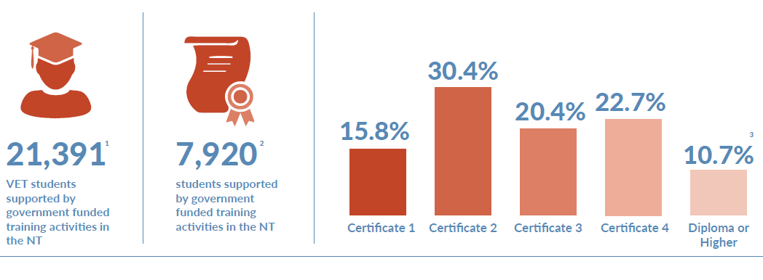
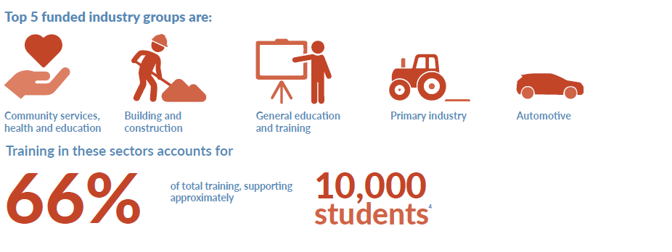
- Workfore NT data extrapolated from 2017 calendar year NCVER publication scope. This includes all Government funded VET activities
- Total VET Activity data 2016 calendar year. Note does not include standalone units of competency completions or skills sets.
- 2016 Total VET Activity collection
- 2017 calendar year Workforce NT data collection

Fifty six per cent of people who were not employed before training gained employment after training.
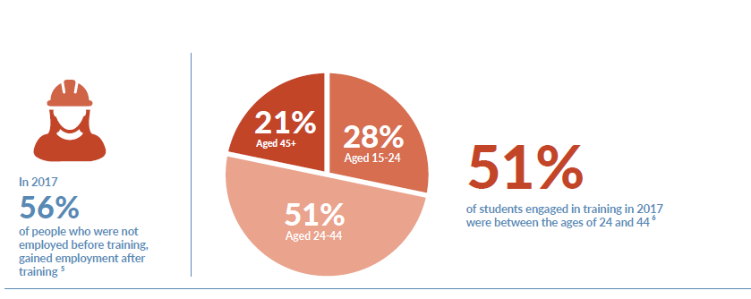
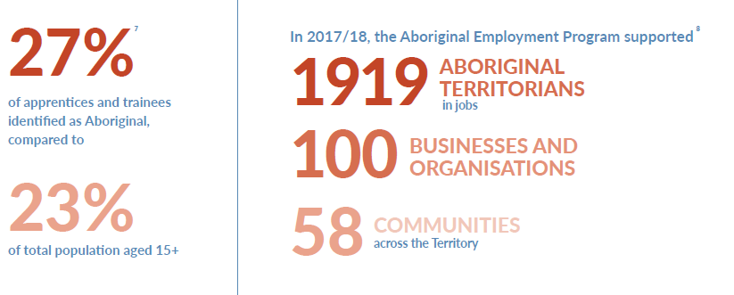
- NCVER collection: Vocstats Government funded Student Outcomes 2008 to 2017
- 2017 calendar year Workforce NT data
- Workforce NT in-training 30 June 2017
- 2017/18 Workforce NT data. A restructure combined the department’s Aboriginal Employment Programs resulting in higher reportable figures

In 2017, the Indigenous Responsive Program (IRP) and the Indigenous Workforce Participation Initiatives Program (IWPIP) were re-shaped to establish the Aboriginal Employment Program (AEP). The program aims to enhance job outcomes in regions and provide targeted case managed services to support employers to develop and retain their workforce. The AEP supported 1919 in jobs, helped 100 businesses and organisations to grow their workforce, and supported 58 communities across the Territory.
The Territory has a strong apprenticeship and traineeship system. In 2017-18, the NT Government committed $28.5 million towards training for apprentices and trainees, including support services to improve retention and completion rates.
Since 2012, apprenticeships and traineeships across Australia have been declining. This is attributed to a number of factors including changes to Commonwealth incentives, economic conditions and labour market structures.
Recent trends in apprenticeships and traineeships indicate improvement, for example, in May 2018 there were 3,318 Territorians undertaking an apprenticeship or traineeship, a 9.8% increase from 2017. The five largest industries funded for apprentices and trainees are:
- utilities
- building and construction
- automotive
- primary industry, and
- community services, health and education
The training delivered in these five areas accounts for about two-thirds of all funding allocated for apprentices and trainees in 2017.
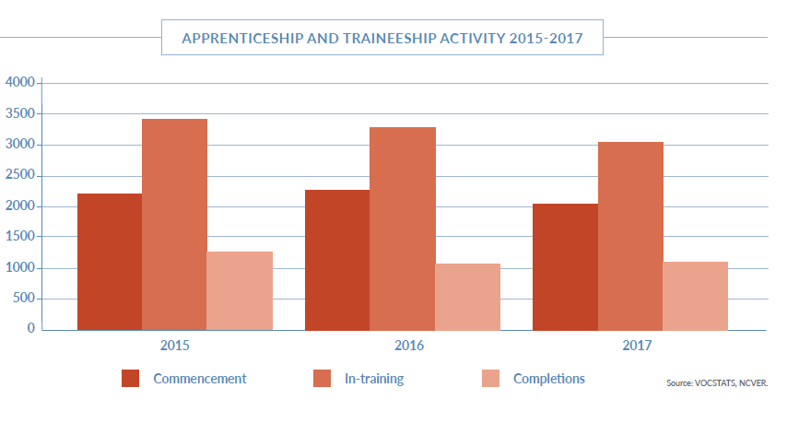

Investment priorities
To build a competitive economy, the NT will need a skilled workforce and Territory businesses will need to build their capacity and capability to compete in national and international markets
Our skills investment is an important pillar to achieve a strong and productive workforce. Government, industry, employers and training providers will have ownership of this shared responsibility to create a sustainable workforce that is vital to our economic growth. We partner with private enterprise designing and delivering programs to better support people entering and staying in the workforce.
The following outlines the government investment priorities.

Economic Development Framework
The Economic Development Framework identifies five key industries as high priority
- Agribusiness
- Tourism
- Energy and minerals
- International education and training
- Defence and support industries
The Economic Development Framework identifies a further five growth sectors at different stages of development. These sectors have high growth potential and promising development opportunities:
- Renewable energy
- Human services
- Tropical health and research, including Aboriginal health and wellbeing
- Environmental services, including Aboriginal land and coastal management
- Creative industries, including Aboriginal art and culture

Major projects
The Government is committed to attracting and delivering new major projects to the Territory to boost the economy. The $40 billion of major projects and infrastructure development across the Territory will focus on job creation. A highly skilled and capable workforce is critical to the success of these projects, which will require a strong and sustainable workforce throughout the implementation, construction and operational stages.

Industry
The Government has significant investment in local industry engagement through the Industry Skills Advisory Council NT and the Australian Council for Private Education and Training (NT). These organisations work with all significant stakeholders across industry, business and the training environment to identify and address skilling and workforce needs to ensure Territory industries and businesses have the capability and capacity to develop and grow.
To achieve the outcome sought by industry, it is vital that skills needs are identified through robust processes and by drawing on the knowledge of industry networks through a collaborative approach. The intelligence provided by industry, forms the evidence base needed to direct skills investments to the right area to ensure skills needs are linked to skills demand.

Cohorts
All Territorians are important to our future economic aspirations and prosperity. The NT Government recognises that increasing access to work for people facing barriers will increase participation in the workforce. Job opportunities will lead to a more independent and improved quality of life. Programs detailed in the plan will seek to support workforce participation of Aboriginal Territorians, people with disabilities and refugees. The NT Government will continue to support apprenticeship and traineeship programs offered to these cohorts, with additional incentive payments.
Strong industry collaboration, genuine partnerships, ongoing engagement.

Regional snapshot
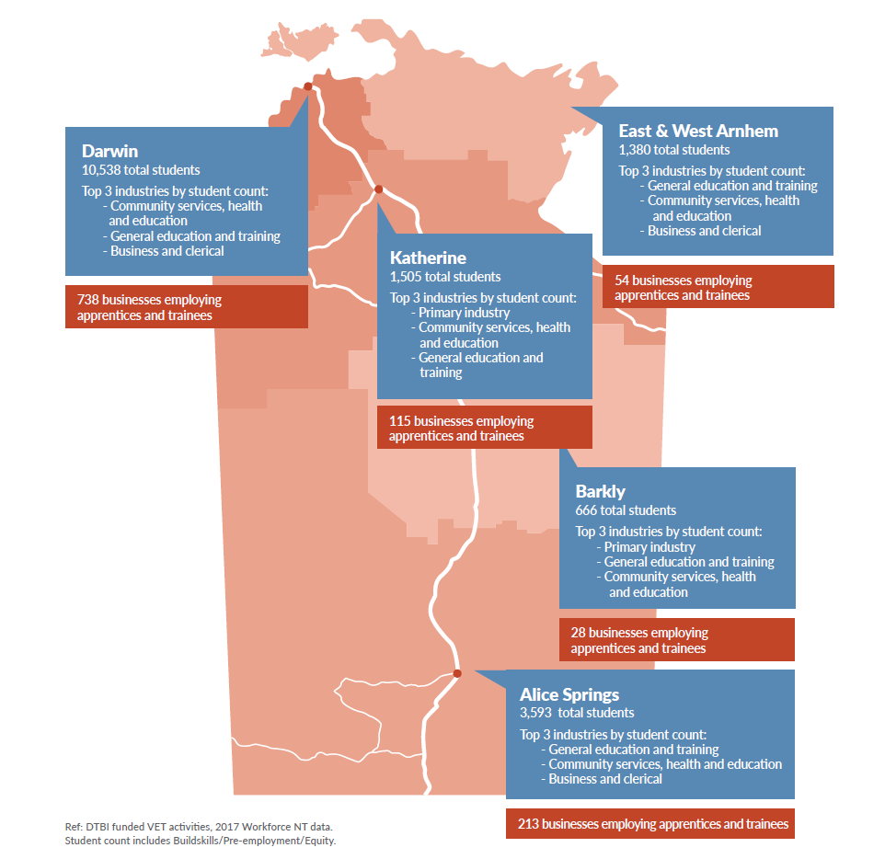

Programs
Investment in services and programs will have the needs of business and industry at its core. Business and industry will need to evolve with the ever-changing environment, particularly economic and technological factors
Government will work closely with the business community to create a sustainable workforce that meets present and future demands. The following outlines the Government’s investment priorities.
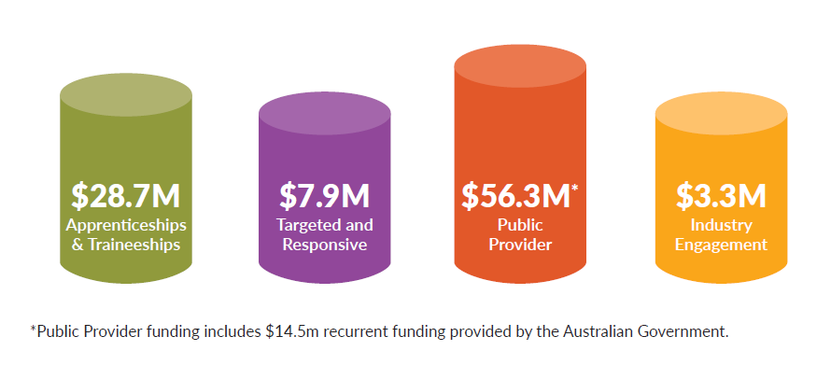

Apprenticeships and traineeships - $28.7 million
Apprenticeships and traineeships are key components of the Skilling the Territory Annual Investment Plan.
Apprenticeships and traineeships combine training and employment that leads to a qualification and builds the employers’ skills base. For an apprentice/trainee, it provides the opportunity to learn, study and earn an income at the same time. For an employer, it is an investment in the future of their business. Apprenticeships and traineeships are valuable contributors to the Territory economy and provide an effective workforce development strategy for small, medium and large businesses.

Training (User Choice) - $21 million
The User Choice program is a demand-driven program that provides support to registered training organisations to train and assess apprentices and trainees in approved apprenticeships and traineeships.
About $8 million of the User Choice Program is contestable, with successful applicants offered calendar year contracts. The non-contestable component of the budget is provided to Charles Darwin University.
The program is advertised annually in major NT newspapers and on the Department of Trade, Business and Innovation’s website.

Employer incentives and apprentice and trainee support - $6 million

Employer Incentives - $4.2 million
The Employer Apprenticeship and Traineeship Support Scheme provides financial support to Northern Territory businesses who employ apprentices and trainees at the Certificate III to Diploma level. The scheme aims to incentivise and compensate businesses for costs associated with employing and training apprentices and trainees.
The Scheme provides a $1,000 incentive when a training contract is registered and an additional $1,000 for employers who are in a regional or remote location, or employing an apprentice/trainee from an identified equity group.

Supercharge Business Bonus
A special feature of the Employer Apprenticeship and Traineeship Support Scheme is a new ‘supercharge’ option, where government can target areas of high priority skills need. The Supercharge Business Bonus provides financial support to NT businesses who employ NT registered apprentices/trainees. The additional financial support aims to assist businesses to retain their apprentices/trainees from commencement through to completion. This contributes to building a skilled workforce and increasing the economic competitiveness of the NT. The Supercharge Business Bonus is available throughout the year subject to government priorities.

Work Wear/Work Gear Bonus - $1 million
First-year apprentices and trainees will continue to benefit from the Work Wear/Work Gear bonus to ensure they have the right tools for their trades, work uniforms and the essential equipment for their job. Payment will be made upfront to the apprentices/ trainees upon registration at the start of their training.
$1000 is available to eligible trade apprentices undertaking training in an occupational shortage trade area and $300 to other eligible registered apprentices and trainees.

Apprentices/Trainees Travel and Accommodation costs - $750,000
An apprentice or trainee undertaking off the job training where the only practical option available is to travel away from home, can apply for financial assistance under the Travel and Accommodation Subsidy Scheme. Eligible apprentices/trainees receive funding to travel from regional and remote communities into town or interstate to complete the off the job training as part of their apprenticeship or traineeship.

Australian Apprenticeships NT - $1.7 million
Australian Apprenticeships NT is contracted by the Australian and Northern Territory governments to administer and regulate the apprenticeship and traineeship system.
Australian Apprenticeships NT as part of the Australian Apprenticeships Support Network assists businesses with the retention and completion of their apprentices. This includes helping with the recruitment of apprentices to ensure the best fit for the employer and the business, complemented by high levels of tailored in-training support provided at any time during the training contract to address issues or challenges that may arise.
Australian Apprenticeships NT offices are located in Darwin, Katherine, Alice Springs and Tennant Creek.

Targeted and responsive - $7.9 million
Targeted and responsive programs provide services for identified skills needs and employment opportunities
The programs are underpinned by Government and industry priorities to ensure publicly funded training programs have a strong link to job outcomes.

New Territory Workforce Program - $3 million
The Territory Workforce Program is a new demand-driven program. The program will support the development and implementation of workforce initiatives to maximise job opportunities for Territorians and strengthen the skills of Territorian’s to meet the needs of business and industry. This new initiative encourages collaboration between business and industry in partnership with government to design customised workforce solutions to improve productivity of Territory employers. The program aims to increase apprentices and trainees across industry and aligns to the National Partnership on the Skilling Australians Fund.

Industry Buildskills Program - $1 million
The Industry BuildSkills Program supports Territory employers to upskill or reskill existing workers in occupations and industry sectors affected by change. This could be new or emerging legislative changes, national codes of practice or technology changes. The program provides skill sets and qualifications in occupations or industry. Applications are open all year until funds are expended.

Aboriginal employment programs - $3.3 million
The Aboriginal employment programs supports the upskilling and re-skilling of Aboriginal people linked to employment outcomes. The $3.3 million committed to a newly-integrated program for Aboriginal employment provides case-managed services for employers to improve local employment opportunities, this can include foundation skills, pre-employment and pre-apprenticeship programs as well as workplace systems to enhance responsiveness to industry change and community opportunities.

Aboriginal Workforce Grants - $970,000
Aboriginal Workforce Grants provide opportunities to support one-off initiatives and projects that will result in more Aboriginal Territorians gaining jobs and staying in them. Aboriginal Workforce Grants include an annual public grant round.

Aboriginal Responsive Skilling Grants - $2.3 million
The Aboriginal Responsive Skilling Grants provides funding for training to meet the needs of Aboriginal people living in urban, regional and remote NT communities. The Aboriginal Responsive Skilling Grant aims to facilitate training activities that lead to employment opportunities for Aboriginal Territorians. Funds are available all year until funds are expended. AEP supports up-skilling of Aboriginal Territorians to enhance their job options, and supports businesses and other organisations to provide jobs.

Pre-Employment Program - $250,000
Pre-employment programs enable people to develop practical skills to help them get a job, apprenticeship or traineeship. Pre-employment funding can support unskilled and semi-skilled people gain the essential skills that will lead to increased opportunities for employment. Pre-employment programs are generally short courses comprising of skill sets identified by industry as essential to entry into an industry or occupation. Funding is available all year round, until funds are fully expended.

Equity Program - $300,000
The Equity Training program supports individuals facing barriers to workforce participation. The program aims to improve employment prospects for people in the following groups:
- People with a disability
- Parents returning to the workforce after an absence of five years or more
- Long-term unemployed migrants
- Refugees
- Mature-aged
- Long-term unemployed people or those at risk of becoming long-term unemployed
- Funds are available all year round or until funds are fully expended.

Public provider investments - $56.3 million

CDU - $44.4 million, Batchelor - $11.9 million
The Northern Territory has two Public Providers, Charles Darwin University (CDU) and the Batchelor Institute. CDU and the Batchelor Institute are significant NT resources providing training, education and research that underpins the economic, social and cultural development of the Territory. The broad contribution the Public Providers make and the integral role they play is a key consideration of the NT Government in the delivery of a skilled workforce through vocational education and training.
The Territory differs from other jurisdictions in Australia, with challenges including remoteness, a small population base and the demographic composition. The contribution our Public Providers make to the community takes on greater meaning and significance in this context.
The NT Government places a high value on the Public Providers engagement in the social and cultural life of the community, contributing to regional and remote training and delivering positive outcomes for Territory students.

Industry engagement - $3.3 million
The Government invests significantly in local industry engagement through the Industry Skills Advisory Council NT and the Australian Council for Private Education and Training (NT). These organisations work with stakeholders across industry, businesses and regions to identify and address skilling and workforce needs to ensure the Territory industries and businesses have the capability and capacity to develop and grow.

Australian Government - $14.5 million*
The Australian Government provides a contribution to training under the National Agreement for Skills and Workforce Development. The NT Government works closely with the Australian Government to leverage funding to maximise support for workforce development initiatives in the Territory. The NT Government will continue to work with the Council of Australian Governments Industry and Skills Council on important national reform initiatives to improve workforce outcomes for individuals, communities, businesses and industry.
* This recurrent funding provided by the Australian Government is included in the Public Provider fund.

Other services
Additional services to support businesses and employers to meet their workforce needs.

Workforce training coordinators
Workforce Training Coordinators provide advice and services to businesses about workforce development and skilling solutions. They provide information and support to address skilling needs through targeted programs that improve employment opportunities
Workforce Training Coordinators are located in Darwin, Katherine, Nhulunbuy, Tennant Creek, Jabiru, and Alice Springs.

Migration support services
Our priority is always to skill Territorians first. We acknowledge that businesses at times need the extra capacity to grow and require skills in areas with ongoing labour shortages. We will work with employers and businesses to support their workforce needs, including options for interstate and overseas skilled migration.

MigrationNT
MigrationNT has carriage of the business and skilled migration program in the Territory. They endorse, nominate or certify a number of visa categories. They also provide information and advice on business and skilled migration programs to NT employers, potential migrants, investors and international students. MigrationNT also advocates for national migration policy changes that support Territory businesses.

Worker Attraction Program
The worker attraction program aims to attract people from interstate and overseas to live and work in the Northern Territory. This will help to expand and diversify the Territory’s skill base. The program also raises the profile of the Northern Territory as a destination of choice and a place to live and work.

Events
The Northern Territory Government hosts a number of events to support businesses and employers to meet their workforce needs

NT Training Awards
The NT Training Awards are a prestigious celebration of excellence in vocational education and training (VET), recognising the achievements of Territorians, businesses and training providers across the VET sector. Now in its 63rd year, the NT Training Awards distinguish those who are the very best in their fields and promotes continuous improvement and innovation in the design and delivery of VET.
The NT Training Awards provides a pathway to national acknowledgement of the Territory’s vocational education and training sector, with NT Training Awards winners provided the opportunity to go on to represent the NT at the Australian Training Awards.

Skills, Employment and careers expo
The Skills, Employment and Careers Expo is the largest training, jobs and careers roadshow in the Northern Territory, attracting over 6,000 attendees and more than 200 exhibitors each year.
Held in Alice Springs, Darwin, Tennant Creek, Katherine and Nhulunbuy, the expo provides a one-stop shop for job seekers, school leavers and those exploring their training and study options.
The expo
- provides an interactive forum for attendees to obtain information on career, training and real-time employment opportunities
- provides businesses, employers and industry bodies the opportunity to engage with and showcase their brands, organisations and industries to our future workforce and clients.

Worldskills
Worldskills is an international movement promoting and building a skills culture by celebrating and showcasing vocational education and training. Skills based competitions operate at regional, national and international levels, and are aligned to National Training Packages, Apprenticeships Australia and Jobs Australia schemes.

The VET investment framework
In September 2017 the NT Government introduced the NT VET Investment Framework which is being rolled out over a number of years.
The Framework sets out a new funding model for investment in vocational education and training to ensure our spending is targeted. The 2018 Annual Investment Plan underpins this Framework, outlining training initiatives, directing funding to priority skill needs and building capacity for developing and growth industries.
Key changes implemented in 2018 which support the implementation of the Framework include:
- the minimum age a student can access subsidised VET has been lowered from 17 to 15. This will enable disengaged school-age students not attending school but able and available to take part in the workforce to access VET training
- the remote location loading has been changed from a set dollar amount to a percentage recognising that the cost of training is higher for some industries in the regions
- NT Government will continue to support foundation skills training to address gaps between high-level skills required in the workplace and the basic skills needed due to factors such as the changing nature of work, impact of advancing technology and workplace demands.
An overview of the Vet Investment Framework can be found on the web site skillingterritorians.nt.gov.au

Key outcomes
The objectives set out in the Annual Investment Plan have direct relationships to a number of key outcomes identified in the Department of Trade, Business and Innovation Strategic Directions 2017 to 2021

Outcomes
- More jobs
- More skilled workforce
- Increased regional workforce participation
- More Aboriginal Territorians in jobs and running businesses

What we will do
- Support Territorians to gain the skills needed to participate in today’s jobs and jobs of the future
- Enable a flexible and responsive vocational education and training system
- Integrated regional economic, business and workforce development plans
- Support employers to meet workforce demands through interstate and international workforce attraction and retention
- Partner to implement the Economic Development Framework
- Position the NT as the destination to live, work, visit, study, do business, trade and invest.

Conclusion
The Annual Investment Plan is underpinned by the broader Government economic agenda
The Plan is part of government’s commitment to work with business and industry to achieve workforce and jobs outcomes.
The plan will:
- deliver a business-centered approach to training and skills development;
- provide the right skills for the right jobs;
- strengthen and support apprenticeship and traineeships;
- facilitate the up-skilling and retention of skilled workers;
- grow the local workforce capacity to support industry; and
- help attract new workers to the Territory.
If you have a proposal that is complementary to the objectives and the investment outlined in this Plan, or if you have any questions or suggestions, we want to hear from you.

Contacts
Workforce NT
Department of Trade, Business and Innovation
GPO Box 3200, Darwin NT 0801
Phone (08) 8935 7707
Email workforceNT.DTBI@nt.gov.au
Web skillingterritorians.nt.gov.au

